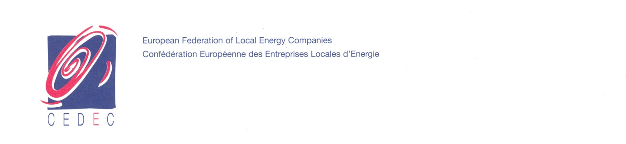

ACER Consultation

on

DFGEB-2012-E-004 FG on Electricity Balancing

CEDEC Comments

Brussels, 25 June 2012

CEDEC defends, at European level, the interests of local and regional energy companies.

CEDEC represents 2000 companies with a total turnover of about 100 billion Euros, and more than 250.000 employees. Together, they serve 75 million electricity and gas customers (connections).

These predominantly medium-sized local and regional energy companies have developed activities as electricity and heat generators, electricity and gas distribution grid operators and suppliers.

Contact details

Name: Gert De Block
Position held: Secretary General
Company: CEDEC
Address: Rue Royale 55 b10
1000 Brussels
Belgium
Contact e-mail: gert.deblock@cedec.com; catherine.biren@cedec.com
Phone : ++32 (0)2 217 81 17
General

CEDEC welcomes the work done by ACER on the common and coordinated treatment of issues concerning the Electricity Balancing, which seems a positive step in the developing Electricity market. CEDEC would like to express thanks to ACER for the opportunity to participate in this consultation. Establishing common ground is necessary to achieve the objectives at European level; it will provide a new phase in the competition in the Electricity industry.

Not all issues raised in the questionnaire have an impact at DSO level, also the impact differs between member states. We limit our answers to the question concerning the imbalance settlement because of the direct influence on DSO level.

Q6:
Do you consider important to harmonize imbalance settlement?
Do you think these Framework Guidelines on Electricity Balancing should be more specific on how to do it?

Answer:
To determine the total imbalance position of a Balance Responsible Party, information of the BRP’s withdrawals and injections on the distribution grids is needed by the TSO. We would like to emphasize that harmonization of this information exchange should not be part of the Framework Guidelines on Electricity Balancing. This information exchange is part of the allocation process. The information exchange and the timelines of the allocation process are very different in every member state. Harmonizing the allocation (and also the reconciliation) process should not be the aim of the Framework Guidelines on Electricity Balancing.
Besides, knowing that the framework guidelines and network codes should only deal with cross border issues, we would like ACER to give motivated reason for including harmonization of imbalance settlement in this framework guidelines and to what extent imbalance settlement is a cross-border issue.

In the case ACER decides nevertheless to harmonize the imbalance settlement or decides to be more specific on how the imbalance calculation is done (besides the imbalance price calculation or the merit order), we would like to point out that DSOs have a special position. This special position was already recognized by ACER in the “Framework Guidelines on Gas Balancing in Transmission Systems”. In that FWGL is stated: “ENTSOG shall involve DSOs in the drafting of relevant sections of the network code, adopting an efficient process of engagement through organizations representing DSOs at a European or, where appropriate, national level.”.

If ACER decides to harmonize the electricity imbalance settlement or to be more specific on how to do this, in the Framework Guidelines on Electricity Balancing, we expect ACER also recognizes the special position of the DSO. We then would suggest ACER adds the following sentence to the Framework Guidelines on Electricity Balancing: “ENTSO-E shall involve DSOs in the drafting of relevant sections of the network code, adopting an efficient process of engagement through organizations representing DSOs at a European or, where appropriate, national level.”

_______________________________________

